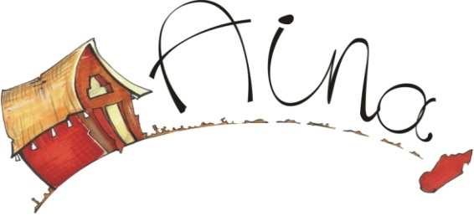

AINA MADAGASCAR
PREMIUM MEMBERHIP
AINA MADAGASCAR’s aims are to promote intercultural exchange, brotherhood, initiative, solidarity between Malagasy and people around the world.
AINA MADAGASCAR focuses on their activities to those three main projects:
- Solidarity trips to the Malagasy Host families or villagers
- Solidarity projects: School extension, Fair trade, basic education in villages of Ankarefo and Beravina
- Promote the Malagasy culture to the countries all around the world
Never underestimate the value of an ordinary decision, In order to help our work and activities, you are not obliged to take a trip in Madagascar but simply join our network; you can be informed of the progress of our work and the update news. By filling the registration and send to the address
AINA MADAGASCAR
Lot BAV025 Beravina Sabotsy Namehana Antananarivo –Avaradrano 102
Tel; Madagascar 263 33 12 173 44 /USA: +1(704) 451 1524/ SWEDEN: 0046 733 107 2 88
Website www.aina-madagascar.org
email: contactainamada@gmail.com Skype: aina.madagascar

MEMBERESHIP ONLY
Name: ……………………………………………………………………………..
Address: …………………………………………………………………………..
Mobile phone: …………………………………………………………………
Email: ……………………………………………………………………………….
Membership N°: ……………………………………………………………..
□ Check □ Cash

I belong to AINA MADAGASCAR:
□ Membership: 10 €
□ Solidarity contribution: 30 €

